Source | Orange Labs, Telecom Italia & Telcordia
Title | FSAN - Test plan for GPON Interoperability plugfest hosted by Telcordia
Project | FSAN Interoperability Task Group
Author | Régis Coat, Paolo Solina & Rob Bond  Orange Labs, Telecom Italia & Telcordia  E-mail: regis.coat@orange-ftgroup.com  E-mail: paolo.solina@telecomitalia.it  E-mail: rbond@telcordia.com
Contributors
Status: | Draft version 0.4
Abstract: | This document informs about specific tests which are recommended for the tests event in the scope of GPON interoperability testing

Tests event Telcordia October 2008
Piscataway, NJ USA

GPON tests definition document
Version V0.3 date: 08/11/2026

Summary

Introduction 3
1 Test Environment Overview 4
1.1 Facility Description 4
1.2 Test Position Description 5
1.3 Optical Distribution Network (ODN) 5
1.4 Test Equipment and Components 6
1.5 Testing Aspects 7
2 Test Cases 8
2.1 Establishment of the OMCC 9
2.1.1 Establishment of the OMCC without encryption 9
2.1.2 Establishment of the OMCC with encryption 10
2.2 Equipment management 11
2.2.1 ONT Bring-up 11
2.2.2 MIB and Alarm Synchronization 13
2.2.3 Discovery 20
2.2.4 Software Image Download 22
2.2.5 Circuit Packs & Dynamic behaviour: Circuit pack provisioning 26
2.2.6 Power Shedding 32
3 Tests Schedule 33
4 Expected result metrics 34
Annex 1: Template for test cases 35
Annex 2: Room plan 36

Revision History

Draft | Date | Description
0.1 | 21-July | Initial draft
0.2 | 04-September | Modified according to comments received after Call #1
0.3 | 26-September | Section 1 revised, including ODN and test setup figures. Modified introductory text in Section 2.2.4 (clarifying that one of the two download test cases is mandatory).  Modified text in 2.2.1.2, 2.2.3.1, and 2.2.5.
0.4 | 7-October | Section 1 revised, including ODN and test setup figures. Modified introductory text in Section 2.2.4 (clarifying that one of the two download test cases is mandatory).  Modified text in 2.2.1.2, 2.2.3.1, and 2.2.5.

Introduction

This document is meant to fully describe the plugfest test plan (including test cases to be used), the test sequence and the enabling test devices and tools available.

Each vendor attending the plugfest should be able to use the information contained in this document to evaluate, and if necessary develop, the capability of its solution to match the intended interoperability assessment tests. This document is also intended to specify the materials and equipment that the participants should bring to the test event.

All feedback is welcome to consolidate the tests proposed.

Test Environment Overview
This section highlights the test environment being provided for the Test Event, including the facilities, test positions, test equipment, and any required ancillary support equipment (e.g., CPE)

Facility Description
A sample layout of the test space is provided below.

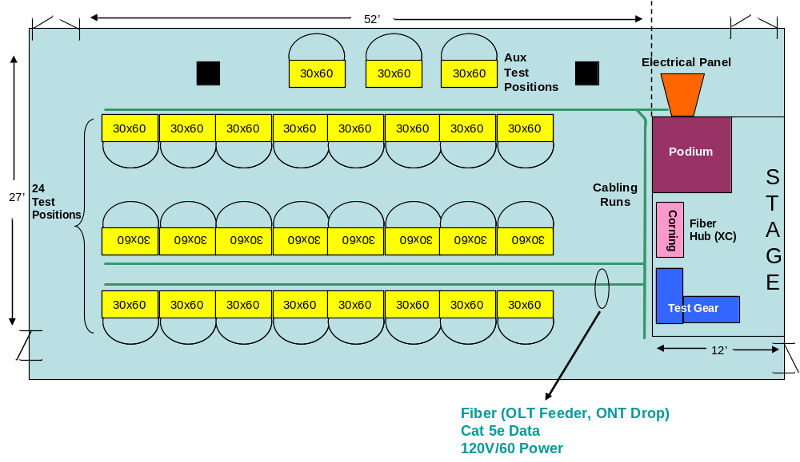
Figure 1: Sample Test Position Layout

The test space consists of up to 24 “test positions” (composed of one 30x60 inch table) grouped into two liner clusters. The “Stage” area is used to locate shared test equipment (e.g., G-PON protocol analyzers, Ethernet traffic generators/analyzers), fiber spools/power splitters, and to facilitate the interconnection between test stations. Participants bringing both OLT and ONU equipment will have two test positions (tables).

Electrical Service: Electrical service in the form of 120 Vac, 60 Hz (15 amp max) service will be provided to each pair of test positions. A six outlet power strip (Type B socket) will be provided per test position. Vendors are advised to bring additional power strips. Vendors requiring other power sources (including DC) should bring the appropriate conversion equipment.

Data Communications/Internet: 802.11 wireless (VPN capable) Internet access will be provided. In addition, a single 10/100BaseT connection can also be made available per test station upon request.

In addition to the facilities described above, the following will be available:
- Network Printer
- Photocopy and fax
- PC with video projector for Test Pairing tracking and Test Results collecting via an electronic “drop-box”.
- Full service cafeteria

Test Position Description
Each test position consists of a 30x60 inch table. A test position is assigned per OLT or ONT. A participant providing both an OLT and ONT will be assigned two test positions.

Each test position will be equipped by the host as follows:

Power: 120VAC/60 Hz, through six Type B sockets

OLT Test Position:
- One SC/UPC termination fiber connecting the OLT to the ODN

ONT Test Position:
- One SC/APC termination fiber connecting the ONT to the ODN via the Corning ClearCurve Fiber Distribution Terminal (FDT) [an SC/UPC termination fiber can be provided if requested by at least two weeks before the event]

Optical Distribution Network (ODN)

Corning will provide a 0 km ODN as illustrated in the figure below.

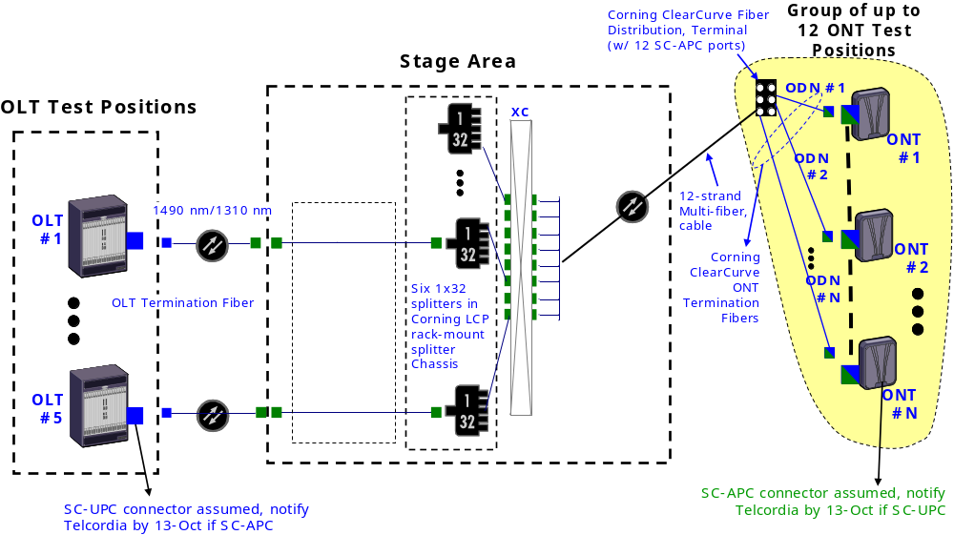

The Corning Local Convergence Point (LCP) cabinet houses the 1x32 power splitters and provides a fiber cross-connect point for interconnecting test pairings. Termination fibers (~50 ft) connect the OLT and ONT to the 1x32 splitter. SC/UPC connectors are assumed for OLT connections. ONT connection to the ODN can be either SC/APC or SC/UPC.

This ODN provides approximately 17 dB of loss. Participants interested in testing in a higher loss environment should insert attenuation in ODN.

Test Equipment and Components
Based on the test cases defined for this event (see Section 2), no external test equipment is required to execute this test plan. Test results will be measured using internal management and control functionality of the OLT and ONT test pair, including debug mode interfaces. Participants are expected to be familiar with how to extract the data necessary of verify compliance with the expected results for each mandatory test case.

Tracespan will provide an optional piece of diagnostic test equipment, their GPON Xpert. This tool will be available to test pairings interesting in troubleshooting behaviors by monitoring the flow of GTC and OMCI layer information between OLT and ONT.

Telcordia will have limited test equipment and test components available to supplement vendor-provided equipment/components.

Other Components – Vendors are expected to bring any other test equipment (power meters, spectrum analyzers), diagnostic tools, programming devices, and support equipment (e.g., laptops, auxiliary power strips, Ethernet patch cords, Ethernet switch/ IP router, DC power suppliers) they feel may be required for the test event, within the space constraints implied by the Facility Description.

Testing Aspects
Participants providing both OLT and ONT equipment to the Test Event are expected to provide adequate engineering support to allow both equipment types to be concurrently engaged in testing.

All test platforms must support OMCI-based provisioning. ONT platforms that require configuration through locally issued commands or scripting (as a substitute for processing OMCI-based commands) are NOT eligible for this event. It is assumed GTC layer functionality of test platforms are stable and mature. Participation in this test event with an ONT that fails to meet this eligibility requirement may result in disqualification from future test events.

Test Cases

The content of this test plan will be focused on Section 7 and 8 of the 5/30/2008 draft version of the OMCI Implementer Guide (embedded below):


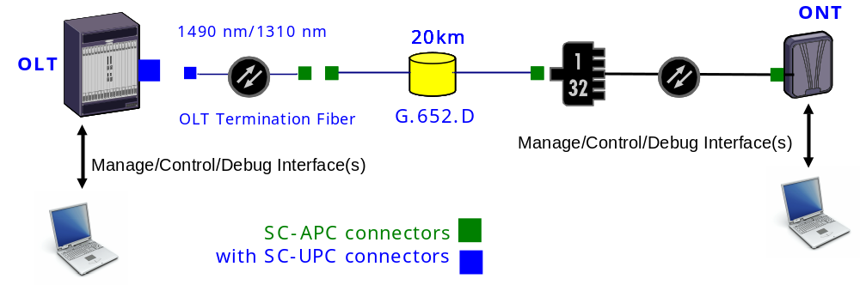
Figure 2: Basic Test Setup

Establishment of the OMCC

Establishment of the OMCC without encryption

Test Case n°1 - Mandatory

Test Setup: Shown in figure n°2

Purpose: The goal of this test case is to test the establishment of the OMCC (no encryption on the OMCC GEM port)

Standard: G.984.3 & G.984.4

Preconditions: no preconditions

Test Equipment: Equipments under test only

Test Procedure
- Build and configure the OMCC via the method described in the OMCI Implementer guide in section 7
- Try to exchange OMCI messages using the OMCC

Pass-fail criteria:
- Method used must be exactly the method described in the OMCI Implementer guide in section 7
- OMCI messages are correctly exchanged and not encrypted

Test report: Pass _____ Fail _____ Not Supported _____

Observation:

Last Modified:

Establishment of the OMCC with encryption

Test Case n°1 - Optional

Test Setup: Shown in figure n°2

Purpose: The goal of this test case is to test the establishment of the OMCC (encryption of the OMCC GEM port)

Standard: G.984.3 & G.984.4

Preconditions: no preconditions

Test Equipment: Equipments under test only

Test Procedure
- Build and configure the OMCC via the method described in the OMCI Implementer guide in section 7
- Enable encryption at the OLT
- Perform a Get on the ONT Vendor ID attribute of the ONT-G ME.
Verify that a correct Get response is received at the OLT .

Pass-fail criteria:
- Method used must be exactly the method described in the OMCI Implementer guide in section 7
- If the Get response to the Get on the ONT Vendor ID is received at the OLT and contains the correct information as verified by the ONT vendor, then the test is considered passed.

Test report: Pass _____ Fail _____ Not Supported _____

Observation:

Last Modified:

Equipment management

ONT Bring-up

New ONT Bring-up

Test Case n°1 - Mandatory

Test Setup: Shown in figure n°2

Purpose: The goal of this test case is to test a new ONT Bring-up

Standard: G.984.3 & G.984.4

Preconditions: no preconditions

Test Equipment: Equipments under test only

Test Procedure
- Proceed the bring-up process for a new ONT via the method described in the OMCI Implementer guide in section 8.1.1
  - After the ONT powers up, and begins execution of a valid software version, the ONT automatically creates its MIB.
  - Once the ONT transitions to Operation-state (O5), the OLT creates the OMCC as described in section 2.1 OMCC Best Practices. Initially, the OLT sets the ONT MIB to its default state by sending a MIB reset to the ONT.
  - Once the ONT receives this message, it re-initializes its MIB to default values, and resets the MIB data sync counter to zero.
  - Next, the OLT sends a MIB synchronization command, uploads the ONT MIB, and retrieves all ONT instances and capabilities.
  - The OLT then downloads MIB updates to the ONT to bring the ONT MIB in synch with the OLT MIB.
  - The OLT sends a Set command for the MIB Sync Counter to the ONT setting it to the same value as the OLT’s counter.
  - The OLT then gets the MIB sync counter from the ONT and verify it with its own.

Pass-fail criteria:
- Method used must be exactly the method described in the OMCI Implementer guide in section 8.1.1
- The Get on the MIB Sync Counter at the end of the test procedure must return the value used in the Set (MIB Sync Counter) command (N) plus 1 (N+1).
- Bring-up process carried without any issues

Test report: Pass _____ Fail _____ Not Supported _____

Observation:

Last Modified:

Old ONT Bring-up

Test Case n°1 - Mandatory

Test Setup: Shown in figure n°2

Purpose: The goal of this test case is to test an old ONT Bring-up

Standard: G.984.3 & G.984.4

Preconditions: ”New ONT bring-up” in previous section already performed

Test Equipment: Equipments under test only

Test Procedure
- Proceed the bring-up process for an old ONT via the method described in the OMCI Implementer guide in section 8.1.2
  - Three possible scenarios are covered in this test case (all these three scenarios must be successfully completed):
1) ONT MIB data sync value matches with OLT’s and is not equal to zero:
    - After successful registration and synchronization of the ONT, disconnect the fiber.
    - Re-connect the fiber to enable ranging of the ONT.
    - If the ONT MIB data sync value matches with OLT’s but is not equal to zero, the OLT assumes that their MIBs are in alignment. The MIB data on both sides of OLT and ONT are identical. The ONT bring-up process is completed.
2) ONT MIB data sync value equals zero:
    - After successful registration and synchronization of the ONT, disconnect the fiber.
    - Manually create a condition at the ONT that forces its data sync value to equal zero.
    - Re-connect the fiber to enable ranging of the ONT.
    - If the ONT MIB data sync value equals zero, the OLT follows the same Bring-up sequence as described for a New ONT.
3) ONT MIB data sync value is non-zero and does not match OLT’s:
    - After successful registration and synchronization of the ONT, disconnect the fiber.
    - Manually create a condition at the ONT that forces its data sync value a different non-zero value.
    - Re-connect the fiber to enable ranging of the ONT.
    - If the ONT MIB data sync value did not match, the OLT executes the MIB synchronization process. If the ONT failed MIB synchronization due to MIB corruption during ONT bring-up, the OLT should re-synchronize the ONT.

Pass-fail criteria:
- Method used must be exactly the method described in the OMCI Implementer guide in section 8.1.2
- Bring-up process carried without any issues

Test report: Pass _____ Fail _____ Not Supported _____

Observation:

Last Modified:

MIB and Alarm Synchronization

MIB Synchronization

MIB data sync attribute

Test Case n°1 - Mandatory

Test Setup: Shown in figure n°2

Purpose: MIB data sync attribute incrementation

Standard: G.984.3 & G.984.4

Preconditions:

Test Equipment: Equipments under test only

Test Procedure
- Verify that the MIB data sync attribute is incremented for the creation and deletion of managed entity instances that are the consequence of a command by the OLT.
- Verify that the MIB data sync attribute is also incremented for attribute value changes which are the consequence of a command by the OLT
- Verify that the MIB data sync counter is not incremented for autonomous creation and deletion of managed entity instances by the ONT itself. Neither is the MIB data sync counter incremented for autonomous changes to attributes of managed entities within the ONT
- Verify that The MIB data sync counter is incremented once per executed command not once per attribute impacted by a command
- Verify that in case of Off-lined ONT, the OLT should only locally update the MIB and increment the MIB data sync so that it guarantees that when the ONT comes on-line, the MIBs audit will fail.

Pass-fail criteria:
- All operation are handled correctly
- All operations must be compliant with the OMCI Implementer Guide

Test report: Pass _____ Fail _____ Not Supported _____

Observation: It is considered good practice for the OLT to not increment its data sync counter until it has received a positive acknowledgement to the command that it sent to the ONT

Last Modified:
Test Case n°2 - Mandatory

Test Setup: Shown in figure n°2

Purpose: Verification of the use of value "0" for MIB data sync attribute

Standard: G.984.3 & G.984.4

Preconditions:

Test Equipment: Equipments under test only

Test Procedure
- Zero is reserved for the following cases:
  - Default MIB with which the ONT left the factory.
  - An ONT which after (re-) initialization cannot restore its MIB.
- Create the conditions where Default MIB with which the ONT left the factory and verify that MIB data sync attribute is equal to 0
- Create the conditions where an ONT which after (re-) initialization cannot restore its MIB and verify that MIB data sync attribute is equal to 0

Pass-fail criteria:
- All operation are handled correctly
- All operations must be compliant with the OMCI Implementer Guide

Test report: Pass _____ Fail _____ Not Supported _____

Observation:

Last Modified:

MIB resynchronization

Test Case n°1 - Mandatory

Test Setup: Shown in figure n°2

Purpose: MIB resynchronisation

Standard: G.984.3 & G.984.4

Preconditions:

Test Equipment: Equipments under test only

Test Procedure
- Create the conditions where the MIB audit operation fails
- Proceed to a MIB resynchronization following the process describer in the OMCI Implementer Guide section 8.2.1.4
- After this operation, MIB audit operation succeeds

Pass-fail criteria:
- All operation are handled correctly
- All operations must be compliant with the OMCI Implementer Guide

Test report: Pass _____ Fail _____ Not Supported _____

Observation:

Last Modified:

Alarm synchronization
When tests in this section require the generation of an alarm at the ONT, the alarm is produced by the removal of the Cat5 cable from the RJ45 associated with the subscriber UNI on the ONT under test. This should result in a LAN-LOS alarm associated with the Ethernet PPTP UNI ME.

Alarm sequence number increase

Test Case n°1 - Mandatory

Test Setup: Shown in figure n°2

Purpose: Verify the ONT capability to inform the OLT of alarm status change by sending alarm status notifications with correct Alarm sequence number, as defined in Pass-fail-criteria.

Standard: G.984.3 & G.984.4

Preconditions: Verify that ARC is not enabled.

Test Equipment: Equipments under test only

Test Procedure
- Produce the alarm at the ONT using the method described in Section 2.2.2.3
- Verify that the OLT receives an alarm status notification

Pass-fail criteria:
- The OLT receives the alarm status notification with the awaited eight-bit alarm sequence number
- All operations must be compliant with the OMCI Implementer Guide

Test report: Pass _____ Fail _____ Not Supported _____

Observation:

Last Modified:

Test Case n°2 - Mandatory

Test Setup: Shown in figure n°2

Purpose: Verify that the OLT is able to detect a wrong eight-bit alarm sequence received with an alarm status notification

Standard: G.984.3 & G.984.4

Preconditions:

Test Equipment: Equipments under test only

Test Procedure
- Disable the sending of alarm status notification to the OLT at the ONT
- Modify the alarm status at the ONT
- Enable the sending of alarm status notification to the OLT at the ONT
- Modify the alarm status at the ONT
- Verify that the OLT receives an alarm status notification and detect a mistake in the eight-bit alarm sequence

Pass-fail criteria:
- The OLT receives the alarm status notification with an un-awaited eight-bit alarm sequence number
- All operations must be compliant with the OMCI Implementer Guide

Test report: Pass _____ Fail _____ Not Supported _____

Observation:

Last Modified:

Test Case n°3 - Mandatory

Test Setup: Shown in figure n°2

Purpose: Verify that the ONT does not send an alarm status notification to the OLT after an alarm under ARC. The alarm sequence number does not change also

Standard: G.984.3 & G.984.4

Preconditions:

Test Equipment: Equipments under test only

Test Procedure
- Create an ARC condition
- Verify that the ONT does not send an alarm status notification to the OLT after an alarm under ARC.
- Verify that the alarm sequence number does not change also
- Disable the ARC condition
- Modify the alarm status at the ONT
- Verify that the OLT receives an alarm status notification with an awaited eight-bit alarm sequence

Pass-fail criteria:
- The ONT does not send an alarm status notification to the OLT after an alarm under ARC. The alarm sequence number does not change also
- All operations must be compliant with the OMCI Implementer Guide

Test report: Pass _____ Fail _____ Not Supported _____

Observation:

Last Modified:

Alarm audit and resynchronization

Test Case n°1 - Mandatory

Test Setup: Shown in figure n°2

Purpose: Alarm audit and resynchronization

Standard: G.984.3 & G.984.4

Preconditions: Test case n°2 section 2.2.2.2.1 -> the OLT detects a gap in the alarm sequence number

Test Equipment: Equipments under test only

Test Procedure
- The OLT then asks the ONT for an alarm status report via the OMCI Command “Get All Alarm”
- The ONT have to acknowledged this demand by a response that contains the number of managed entity instances that have outstanding alarms
- The OLT then requests the alarm status of all these managed entity’s instances
  - The OLT must issue as many GetAllAlarmsNext requests as the number of instances given in the GetAllAlarms response. The maximum time between two GetAllAlarmsNext requests is 1 minute.
- The OLT then compares the received alarm statuses with its own alarm table entries for that ONT
- The alarm sequence number is reset to zero by the ONT when it receives the alarm status report demand from the OLT

Pass-fail criteria:
- Verify that the maximum time between two GetAllAlarmsNext requests is 1 minute
- All steps of the test procedure have to be finalized in a correct way using the method described in section 8.2.2.2 of the OMCI Implementer Guide

Test report: Pass _____ Fail _____ Not Supported _____

Observation:

Last Modified:

Discovery

Discovery of ONT physical capabilities via MIB UPLOAD

Test Case n°1 - Mandatory

Test Setup: Shown in figure n°2

Purpose: Discovery of ONT physical capabilities via MIB upload

Standard: G.984.3 & G.984.4

Preconditions:

Test Equipment: Equipments under test only

Test Procedure
- Initiate a new ONT on a PON tree
- The ONT has to populate its MIB with information about its equipment prior to ranging of the ONT

- After ranging, the OLT will use the MIB Upload operation by performing a MIB upload request to determine the current hardware configuration of the ONT

- The OLT then discovers the hardware configuration of the ONT by analysis of the uploaded MIB configuration

Pass-fail criteria:
- The ONT physical capabilities detected at the OLT must reflect the real ONT physical capabilities, and should include the physical capabilities listed in the table below.
- All operations must be compliant with the OMCI Implementer Guide

Table 1: ONT Physical Capabilities

ONT Physical Capability | Values Reported By OLT
Card Holder Support
number of card holders | For each card holder:  - Is the card holder integrated or pluggable?  - Actual unit type  - Actual equipment id  - Indication if it supports protection (if non zero)
Circuit pack
virtual circuit pack | Number of ports
Pluggable¹ | Number of ports
Port Mapper
virtual circuit pack | Port interface types if different than indicated in the card holder
Pluggable¹ | Port interface types if different than indicated in the card holder
ONT-G based | Port interface types which are not referenced by the card holder or virtual circuit pack
Other
Equipment extension package support | Detection of Equipment extension package ME (0 or 1)
Protection data | Detection of Protection data ME (0 or 1)
ONT Image bank information | List the values of Version, IsCommitted, IsActive, and IsValid for both images
TCONT resource information | List the following:  1. Number of instances of the T-CONT ME  2. Total T-CONT number attribution of ANI-G  Editor’s Note: Although these 2 values should align, it was decided to include both for verification
Priority Queue resource information | Number of instances of the Priority Queue-G ME
Traffic Scheduler information | Number of instances of the Traffic scheduler-G ME
Power Shedding awareness | Number of instances of the ONT power shedding ME (0 or 1)
IP Host awareness | Number of instances of the IP host config data ME
VoIP support awareness | supported configuration modes  Editor’s Note: don’t know how best to indicate this or if this should be included
IGMP support awareness | Existence of the Multicast operations profile ME
Remote debug awareness | Detection of the ONT remote debug ME (0 or 1)
OMCI entity capability | Detection of the OMCI ME (0 or 1)
OMCC version information | OMCC version attribute of the ONT2-G ME
Battery backup support | Battery backup attribute of the ONT-G ME
Traffic management type | Traffic management option attribute of the ONT-G ME
Vendor product type / equipment id | Vendor id, Version, and Serial number attributes of the ONT-G ME
Status reporting DBA information | SR indication, Piggyback DBA reporting and Whole ONT DBA reporting attributes of the ANI-G ME
¹after the ‘expected type’ is set in the card holder by the OLT

Test report: Pass _____ Fail _____ Not Supported _____

Observation:

Last Modified:

Discovery of ONT software capabilities -- OMCI Capability Report

Test Case n°1 - Optional

Test Setup: Shown in figure n°2

Purpose: Discovery of ONT software capabilities

Standard: G.984.3 & G.984.4

Preconditions:

Test Equipment: Equipments under test only

Test Procedure
- The GPON system should support ONU software capability reporting through the discovery of the managed entity types and message types supported by the ONU. This is accomplished through the reading of two table attributes contained within the OMCI ME
- The OLT obtains the managed entity types supported by the ONU through the managed entity type table attribute of the OMCI ME.
- The OLT obtains the message types supported by the ONU through the “message type attribute” of the OMCI ME

Pass-fail criteria:
- The ONT support of OMCI objects and attributes detected at the OLT must reflect the real ONT software capabilities
- All operations must be compliant with the OMCI Implementer Guide

Test report: Pass _____ Fail _____ Not Supported _____

Observation:

Last Modified:

Software Image Download
This section contains two sets of test cases (Set #1 = Section 2.2.4.1 and Set #2 = Sections 2.2.4.2 & 2.2.4.3), of which the participants must perform at least one. The first set uses a software image “proxy” file that is used to test the OMCI mechanism for ONT software download without using an actual ONT binary image. The second set of test cases (section 2.2.4.2/3) are an alternative to the first set and makes use of an actual ONT software image. The second set of Test Cases also tests the Commit and Activate process.

Software Download - Image Proxy
Test cases in the section are mandatory unless the test cases of Section 2.2.4.2 and 2.2.4.3 are executed, in which case these test cases can be viewed as optional. If test cases in this section are executed, those in Section 2.2.4.2 and 2.2.4.3 can be omitted.

A test download file will be used containing a file header that can be identified by the ONT as a ‘fake’ image, which also has an embedded file position markers (to assist in debugging). The CRC shall be documented so that both vendors can ensure that the CRC generation code on both sides matches the expected result.

The proposed file shall have the following information and format:

- The first 32 bytes shall be 0x5448495320495320412046414B4520444F574E4C4F4144000000000000000000 (ASCII string for THIS IS A FAKE DOWNLOAD<NULL>….<NULL>)
- The remainder of the file shall have a 32 byte pattern of:
0xVVVVVVVV207365676D656E642030313233343536373839414243444546200000, where VVVVVVVV is the ASCII representation of a hex counter from 0000 to 02FE. (ASCII string for first pattern is:
0000 segment 0123456789ABCDEF <NULL><NULL>)
- The file size shall be 24576 bytes (32 x 768)
- This size was selected to have the repeating byte pattern be aligned to a segment, and the file shall contain enough segments that multiple full windows will be used if the maximum segment size is selected.
- The CRC of this file shall be of 2 potential values, depending on the CRC method used
- I.363.5 yields CRC=0x9E28469C, where MSB sent first in time
- 802.3 yields CRC=0xA022CC6B, where LSB sent first in time
- The proposed file shall be made via the interop FTP site

Embedded below is a candidate proxy software image download file with these characteristics : 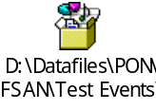

Test Case n°1 : Proxy Image Download

Test Setup: Shown in figure n°2

Purpose: Download of a software image

Standard: G.984.3 & G.984.4

Preconditions:
- ONT software shall be able to detect the test software image, and accept the download file if properly received (with matching lengths and CRC information). This image should NOT be stored in flash, nor should the version information of the corresponding image entity be updated.

Test Equipment: Equipments under test, test software image

Test Procedure
- Download a test software image following the procedure explained in the OMCI Implementer Guide section 8.4.2

Pass-fail criteria:
- The download of the software image is processed correctly
- The OLT calculated CRC should match the published CRC value
- The sent CRC value should match the published CRC value
- The ONT calculated CRC on the received data should match the published CRC value
- The OLT receive an acknowledgement from the ONT
- All operations must be compliant with the OMCI Implementer Guide

Test report: Pass _____ Fail _____ Not Supported _____

Observation:

Last Modified:

Test Case n°2 : Proxy Image Download Error Handling

Test Setup: Shown in figure n°2

Purpose: Problem during Download of a software image

Standard: G.984.3 & G.984.4

Preconditions:

Test Equipment: Equipments under test, test software image

Test Procedure
- Download a software image following the procedure explained in the OMCI Implementer Guide section 8.4.2
- During the download, create an error

Pass-fail criteria:
- The download of the software image is not processed correctly and the software image is not useable
- The OLT receive a negative acknowledgement from the ONT
- All operations must be compliant with the OMCI Implementer Guide

Test report: Pass _____ Fail _____ Not Supported _____

Observation:

Last Modified:

ONT Software Image Download
Test cases in the section are mandatory unless the test cases of Section 2.2.4.1 are executed, in which case these test cases can be viewed as optional. If test cases in this section are executed, those in Section 2.2.4.1 can be omitted.

If test cases in section are executed, those in this section can be omitted.

Test Case n°1 - Optional

Test Setup: Shown in figure n°2

Purpose: Download of a software image

Standard: G.984.3 & G.984.4

Preconditions:

Test Equipment: Equipments under test only

Test Procedure
- Download a software image following the procedure explained in the OMCI Implementer Guide section 8.4.2

Pass-fail criteria:
- The download of the software image is processed correctly and the software image is useable
- The OLT receive an acknowledgement from the ONT
- All operations must be compliant with the OMCI Implementer Guide

Test report: Pass _____ Fail _____ Not Supported _____

Observation:

Last Modified:
Test Case n°2 - Optional

Test Setup: Shown in figure n°2

Purpose: Non Recoverable Problem during Download of a software image

Standard: G.984.3 & G.984.4

Preconditions:

Test Equipment: Equipments under test only

Test Procedure
- Download a software image following the procedure explained in the OMCI Implementer Guide section 8.4.2
- During the download, create a non recoverable error by sending an incorrect CRC of the Software image in the End Software download command.

Pass-fail criteria:
- The download of the software image is not processed correctly and the software image is not useable
- The OLT receive a negative acknowledgement from the ONT
- All operations must be compliant with the OMCI Implementer Guide

Test report: Pass _____ Fail _____ Not Supported _____

Observation:

Last Modified:
Test Case n°3 - Optional

Test Setup: Shown in figure n°2

Purpose: Recoverable Problem during Download of a software image

Standard: G.984.3 & G.984.4

Preconditions:

Test Equipment: Equipments under test only

Test Procedure
- Download a software image following the procedure explained in the OMCI Implementer Guide section 8.4.2
- During the download, create a recoverable error. A recoverable error could be “Software image section number out of order”, or “section number greater that the size of window negotiated”.

Pass-fail criteria:
- The download of the software image is processed correctly and the software image is useable
- The OLT receive a negative acknowledgement from the ONT for the downloaded section with the error. OLT resends the section without an error.
- All operations must be compliant with the OMCI Implementer Guide

Test report: Pass _____ Fail _____ Not Supported _____

Observation:

Last Modified:

Activate and Commit
Test cases in the section are mandatory unless the test cases of Section 2.2.4.1 are executed, in which case these test cases can be viewed as optional. If test cases in this section are executed, those in Section 2.2.4.1 can be omitted.

Test Case n°1 - Optional

Test Setup: Shown in figure n°2

Purpose: Commit and Activate of a software image

Standard: G.984.3 & G.984.4

Preconditions: Test case n°1 of section 2.2.4.1

Test Equipment: Equipments under test only

Test Procedure
- After a positive acknowledgement is sent by the ONT, the valid software image will be loaded and executed by the ONT without changing the committed state.
- The OLT may then send the Commit image command, causing the ONT to set its commit state to a one and to send a Commit image responseDownload a software image following the procedure explained in the OMCI Implementer Guide section 8.4.3

Pass-fail criteria:
- After a reboot, the ONT has to run the good software image
- All operations must be compliant with the OMCI Implementer Guide

Test report: Pass _____ Fail _____ Not Supported _____

Observation:

Last Modified:
Test Case n°2 - Optional

Test Setup: Shown in figure n°2

Purpose: Attempt to activate a non-operational software image

Standard: G.984.3 & G.984.4

Preconditions: The ONT is operational, and the active software image instance is valid and committed.

Test Equipment: Equipments under test only

Test Procedure
- Read and record the active software image attributes, verify it is valid and committed, and record the software image version.

- Download the proxy software image of Section 2.2.4.1
- Upon receipt of a successful End_Software_Download response, issue an Activate_Image command on the downloaded but uncommitted software image instance.

Note: If after downloading, verifying and activating there is still a problem with the image that causes the ONT to fail (e.g. watchdog timers detects activation failure), then the ONT should do a soft restart to the committed image. In this way, activating prior to committing may allow for automatic failure recovery by the ONT.

Pass-fail criteria:
- Verify that the ONT restarts successfully with the active software image instance being valid and committed, and its version being unchanged.

- Verify that the inactive software image instance is invalid.

Test report: Pass _____ Fail _____ Not Supported _____

Observation:

Last Modified:

Power Shedding

Test Case n°1 – Optional (for ONT supporting Power Shadding)

Test Setup: Shown in figure n°2

Purpose: Verification of OMCI provisioning of ONT Power Shedding

Standard: G.984.3 & G.984.4

Preconditions:

Test Equipment: Equipments under test only

Test Procedure
- Verify that the Power Shedding ME is auto-created by an ONT if that ONT supports power shedding
- The verification of reduced power dissipation, the verification of service shutdown, the verification of service class specific shedding intervals, and the verification of service class restoral after power restoration are out of scope

Pass-fail criteria:
- All operations are handled correctly
- All operations must be compliant with the OMCI Implementer Guide

Test report: Pass _____ Fail _____ Not Supported _____

Observation:

Last Modified:

Tests Schedule
The following provides a proposed weekly test schedule. The schedule allows for two test sessions per day, except for Monday. There are a total of 7 test sessions throughout the event, with each test session having at most x parallel test pairings (where “X” is the number of OLTs participating).

The 7th Test Session (PM of Thursday 30-Oct) is proposed to be a free session, with no pre-defined test pairings. This provides an opportunity for retesting. Participants are responsible for determining how to use this time.

Monday | 08.00 -12.00 | Set up time for all participants
 | 12.00 – 13.30 | Lunch
 | 13.45 – 19.00 | Test Session #1 (up to x active pairings)
 | 19.15 | Closing test room
Tuesday | 7.00 | Room opening
 | 08.00 - 13.00 | Test Session #2 (up to x active pairings)
 | 13.00 - 14.00 | Lunch
 | 14.00 – 19.00 | Test Session #3 (up to x active pairings)
 | 19.15 | Closing test room
Wednesday | 7.00 | Room opening
 | 08.00 - 13.00 | Test Session #4 (up to x active pairings)
 | 13.00 - 14.00 | Lunch
 | 14.00 – 19.00 | Test Session #5 (up to x active pairings)
 | 19.15 | Closing test room
Thursday | 7.00 | Room opening
 | 08.00 - 13.00 | Test Session #6 (up to x active pairings)
 | 13.00 - 14.00 | Lunch
 | 14.00 – 19.00 | Test Session #7 (free pairings – no pre-scheduled pairings)
 | 19.15 | Closing test room
Friday | 7.00 | Room opening
 | 07.00 - 12.00 | Equipment break-down
NOTE: A social event is planned for Tuesday or Wednesday evening, which may necessitate an early start and stop time (e.g., 5:30 PM) for that day.

Expected result metrics

20 minutes before the end of each pairing, OLT vendors and ONT vendors will have to fill a specific document (See embedded file).

Annex 1: Template for test cases

Template for test cases

Test Case #

Test Setup

Purpose:
.

Standard:

Preconditions:
.

Test Equipment:
.

Test Procedure
1. .

Pass-fail criteria:
.

Test report: Pass _____ Fail _____ Not Supported _____

Observation:

Last Modified:

Annex 2: Room plan
This section provides the test position assignments for each participating company and will be updated once the participant list is finalized. Each OLT and ONT receives a test position. Twenty test positions are shown below, accommodating the X OLTs and Y ONTs participating in the Test Event. Participants providing both equipment types have been assigned two test position. A test position is a 60 x 30 (LxD) inch table.

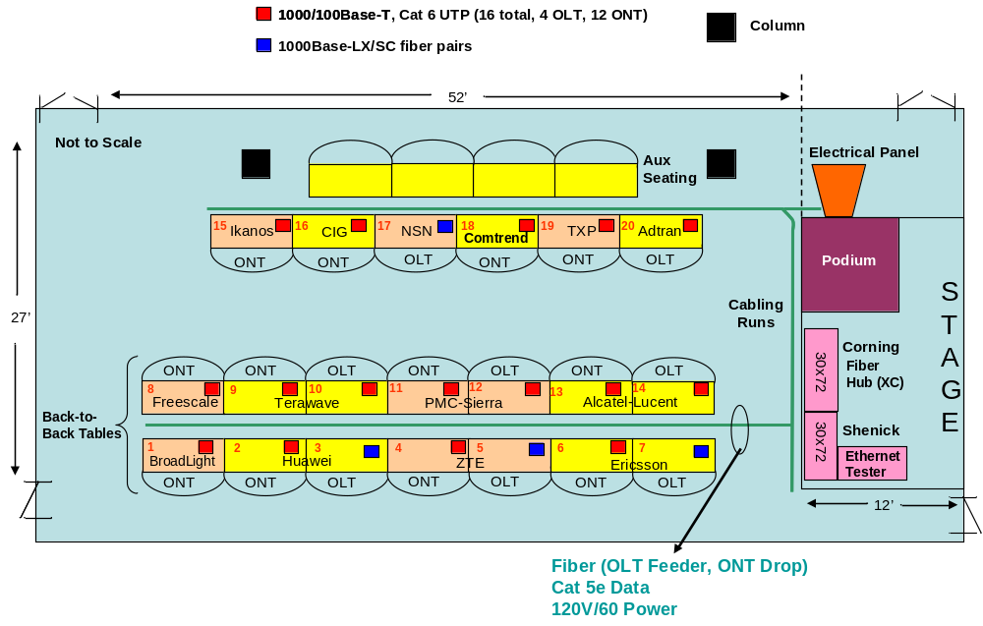

NOTE: This is the October 2007 assignment plan. It will be revised once the list of participants is finalized.

Editor note: This issue has come up before during BPON interoperability, where CRCs in reference to files was done using the 802.3 method which is used for files, or the I.363.5 method as used for the OMCC CRC. It is recommended that this be discussed to bring alignment to the test plan and to give better success to interoperability. In fact, the vendors authoring this text (i.e., Motorola and Adtran) have differing approaches, which is how this issue came up again.
Editor Note: This needs to be defined. The download method has build in retry methods to handle basic error conditions such as impaired bytes, a missing downstream (non-acknowledge) message segment [each of which could also warrant separate test cases]. Examples of other error conditions that may be valid here is the OLT sending a window that exceeds the ONT window maximum, or a misalignment of the CRC values from the expected value.

